**Stu.ID: 21100358 Name:**

**Answer Sheet_Lab 1: I-V Curve and Diodes**

**Task 1 – Hardware Construction:**

c.

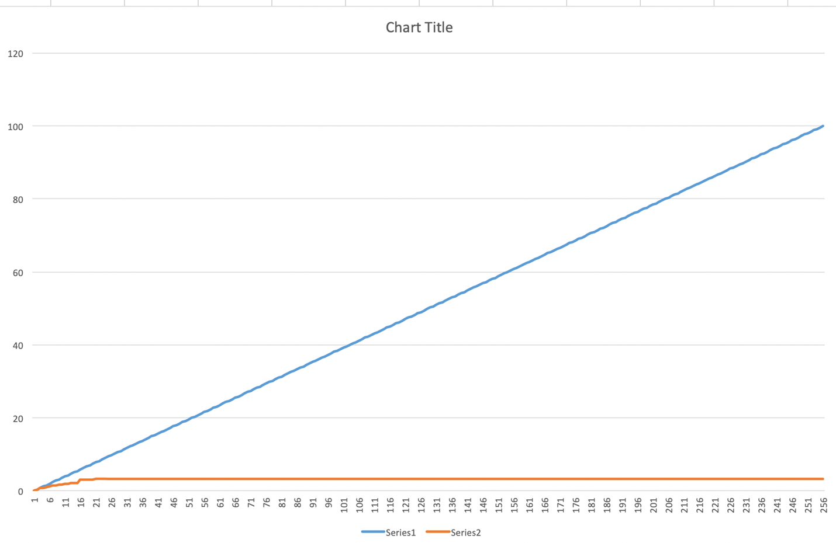

**d.**

The data suggests 𝑉out is limited to about 3.3V even as duty cycle increases beyond a certain point. This could represent a voltage regulator or a system output voltage saturation limit.

**Task 2 – Measurement of a resistor**

**Exercise:**

d.

e.

1)

2)

3)

4)

5)

**Task 3 – Measurement of 1N4148 diode:**

d.

**Task 4 – Measurement of Zener diode:**

d. 3.3 V Zener Diode

e. 2.7 V Zener Diode

**Question: From Task 2 to Task 4, can you identify the features of the general resistor, 1N4148 diode and Zener diode?**

**PLEASE UPLOAD THE ANSWER SHEET TO CANVAS/ASSIGNMENTS/LAB 1**